My sender email account is: workspace. Please guide me through the correct Gmail API OAuth setup.
Since nitin.g@iksula.com is a Google Workspace company account, I recommend configuring Gmail API with Internal OAuth consent + Web application credentials + offline access.
This is suitable for your timesheet reminder application because it can send emails automatically without requiring you to sign in every time.
Follow these steps.

Step 1. Create a Google Cloud project
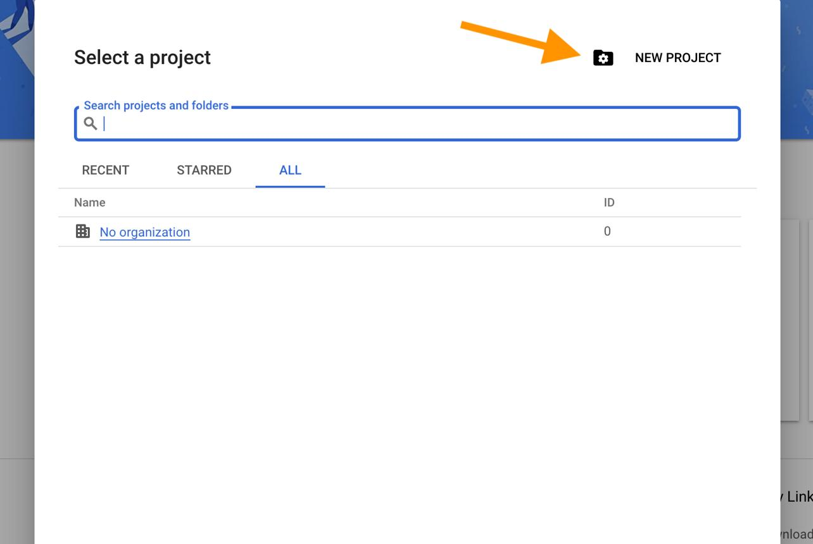
- Open Google Cloud Console.
- Sign in with your company Google Workspace account.
- Click the project selector at the top.
- Click New Project.
- Enter:
  - Project name: Timesheet Reminder Automation
  - Organization: Your company organization, if available.
- Click Create.

Step 2. Enable Gmail API
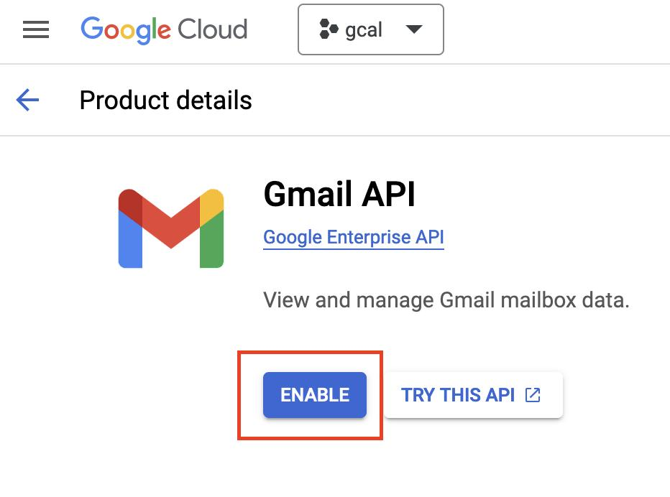
- Open Gmail API.
- Select your newly created project.
- Click Enable.

Step 3. Configure OAuth consent screen
Open Google Auth Platform.
Click Get Started if prompted.
Configure the following:
Field | Value
App name | Timesheet Reminder
User support email | Your company email
Audience | Internal
Contact email | Your company email
Important: Select Internal only if your Google Cloud project belongs to your company's Google Workspace organization and the sender account is within that organization.
Save the configuration. Google documents this setup in its Gmail API Node.js setup guide.
Google for Developers

Step 4. Configure Gmail sending permission
Open Google Auth Platsform → Data Access.
Add this scope:
Required OAuth scope https://www.googleapis.com/auth/gmail.send
This permission allows your application to send emails on behalf of the authorized account. It does not grant general mailbox-reading access.
Google for Developers

Step 5. Create OAuth Client ID
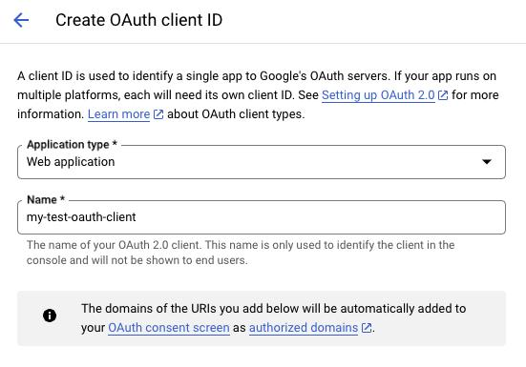
- Open Google Auth Platform → Clients.
- Click Create Client.
- Select Web application.
- Name it Timesheet Reminder Web Client.
- Add the authorized redirect URI.
For the redirect URI, ask Claude Code to provide the exact callback URL from your application. For example, during local development it might be:
http://localhost:3000/api/auth/google/callback
Do not use this example unless it matches your actual application route.
6. Click Create.
You will receive:
- Client ID
- Client Secret
Keep both secure.
Google for Developers+1

Step 6. Generate Refresh Token
This step must be implemented by your application developer.
Your backend should:
- Redirect you to Google's authorization page.
- Ask you to sign in using nitin.g@iksula.com.
- Request the gmail.send permission.
- Request offline access.
- Receive the authorization code at your redirect URI.
- Exchange that code for access and refresh tokens.
- Store the refresh token securely.
Google's official instructions: Server-side OAuth authorization.
Google for Developers
Important: A refresh token is generally issued during the initial authorization when offline access is requested. Your backend must securely retain it.

Step 7. Enter credentials in your Timesheet Dashboard
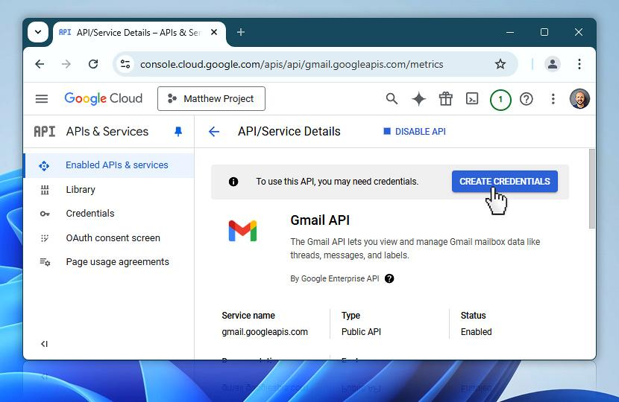
Dashboard field | What to enter
Provider | Gmail API
From address | nitin.g@iksula.com
From name | Timesheet Reminder
Reply-to | nitin.g@iksula.com
OAuth Client ID | Google-generated Client ID
OAuth Client Secret | Google-generated Client Secret
Refresh Token | Generated by your application OAuth flow
Click Test connection.
The backend should send a test email to the configured sender or an approved test recipient and display success/failure.

Step 8. Google Workspace administrator approval
Important for company accounts
Your company's Google Workspace administrator may need to approve the OAuth application because gmail.send is a sensitive scope.
Ask your Workspace administrator to:
- Open Google Admin Console.
- Navigate to Security → Access and data control → API controls.
- Open Manage Third-Party App Access.
- Locate or configure your OAuth application using its Client ID.
- Review the Gmail sending scope and grant the appropriate access.
The administrator's access-control policies can block OAuth applications even when the user has completed consent.
Google Workspace Help+1

Claude Code instructions
You can give Claude Code the following implementation requirement:

Gmail API Integration – Timesheet Reminder Automation
Implement Gmail API OAuth 2.0 integration for the company Google Workspace sender account nitin.g@iksula.com.
Requirements:
- Use Google OAuth 2.0 Web Application credentials.
- Support Internal Google Workspace OAuth applications.
- Request only this scope:
https://www.googleapis.com/auth/gmail.send
- Use offline access and securely obtain and persist the refresh token.
- Implement a backend OAuth authorization and callback flow.
- Add a Connect Gmail / Authorize Gmail button in the Email Provider settings.
- Display connection status: Not Connected, Connected, Failed, or Authorization Expired.
- Implement Test Connection functionality that sends a test email.
- Use the authenticated Gmail account as the sender.
- Store Client Secret and Refresh Token encrypted on the backend. Never expose credentials in frontend code, logs, or Git.
- Handle token refresh, revoked authorization, API errors, and retries.
- Ensure scheduled reminder emails can be sent automatically without requiring manual login each time.
Sender configuration:
- Email: nitin.g@iksula.com
- Sender name: Timesheet Reminder
- Provider: Gmail API
Do not ask users to manually paste a refresh token if the application can generate it through the OAuth authorization flow.
Provide setup instructions for Google Cloud Console and Google Workspace administrator approval.

Let's proceed with your setup
First, can you access the Google Cloud Console using your company email?
- Yes, I can access it.
- No, I need IT/admin permission.
- I can access it, but I cannot create a project.
Based on your answer, I'll guide you through the next screen.

